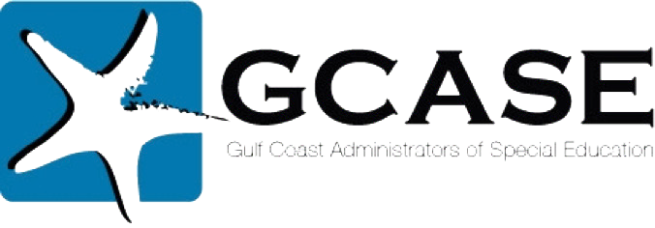
GCASE Annual Law Conference

December 13, 2018
Houston Galleria

Legislative Agenda 2019: Forecast for Educators – Thompson Horton, LLP
Safety, Security & Students with Disabilities – Powell-Leon, LLP
The Year in Review: Relevant Case Law for Special Education – Rogers, Morris & Grover, LLP
The 504, MDR & Special Education Triangle – Walsh Gallegos P.C.

Members $150, Non- Members $175
Registration coming in October www.gcasehouston.com

